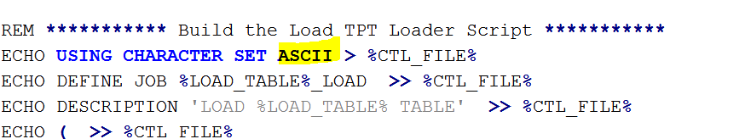

ASCII should not be hard coded – it should come as a variable from this screen:

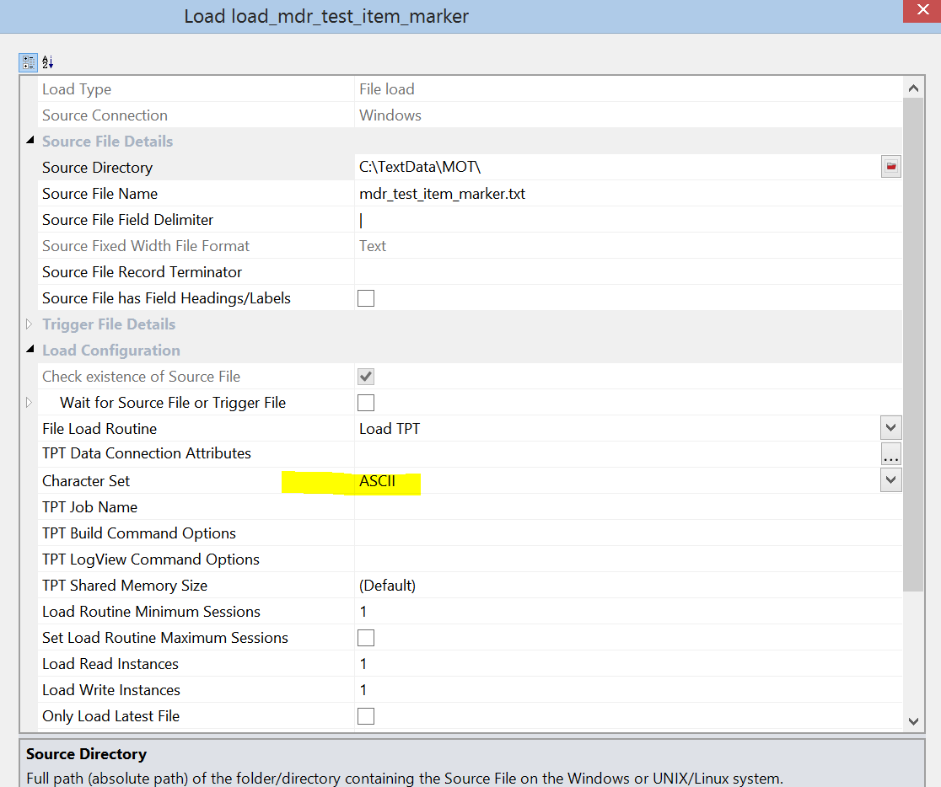

If you send me how to reference everything associated with load metadata (in ws_zt_load_tab & ws_zt_load_col, then I’ll build the TPT File script in my sleep. This Character Set is a key thing and people do change it. But that’s just one of many, so if you send me the answer on how to reference then we’re golden.